**Assg-06 DB Ball GUI**

**Esraa Abdelmoein**

**2025-10-16**

**Create a Ball GUI that allows the user to add ball data (name, x, y, dx, dy, colour).**

**Include EditTexts for:**

**Name input:**

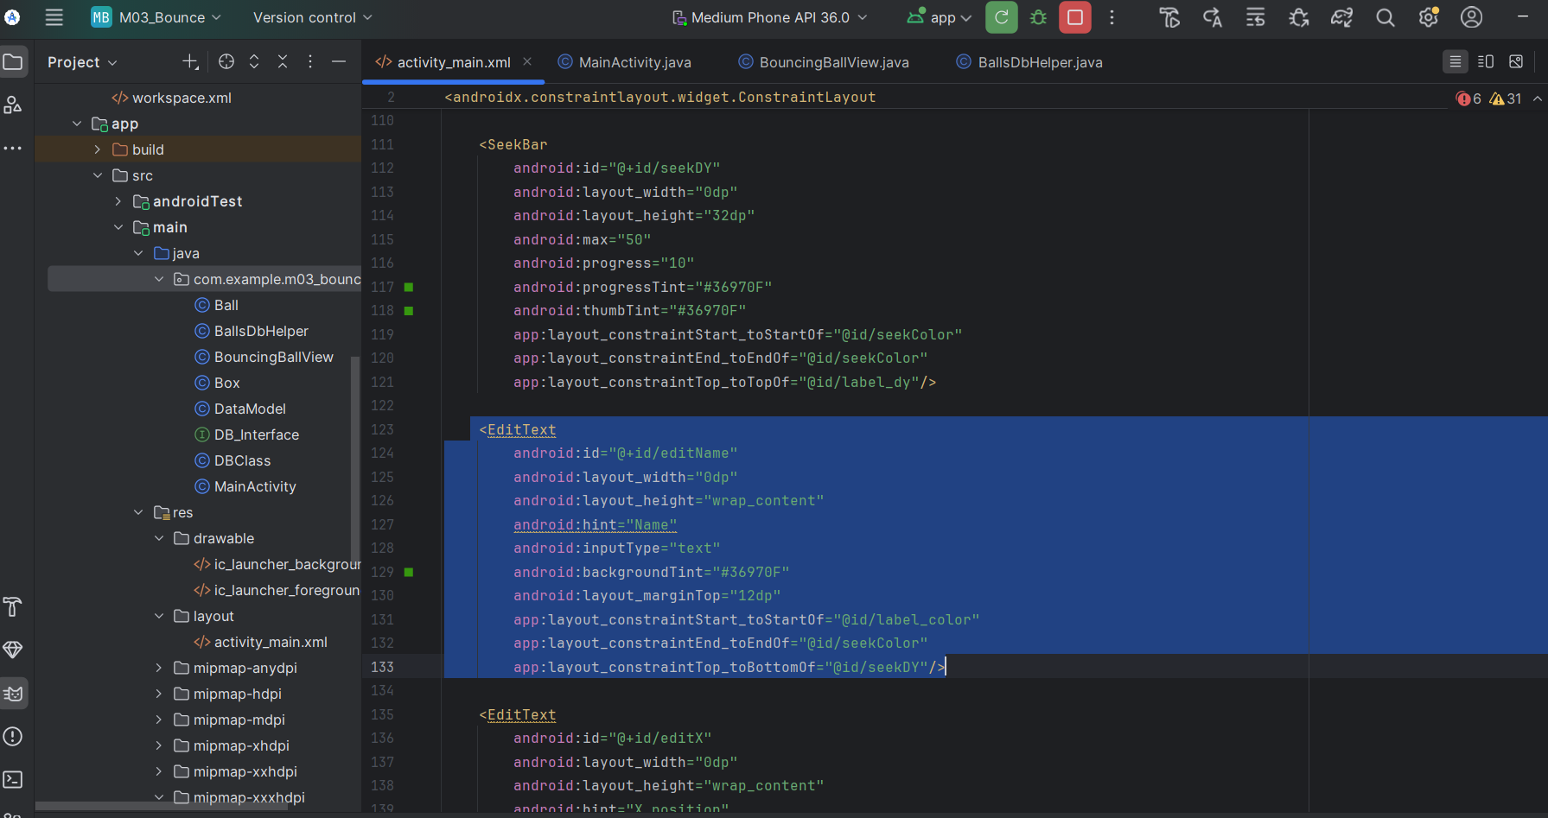

**Color input:**

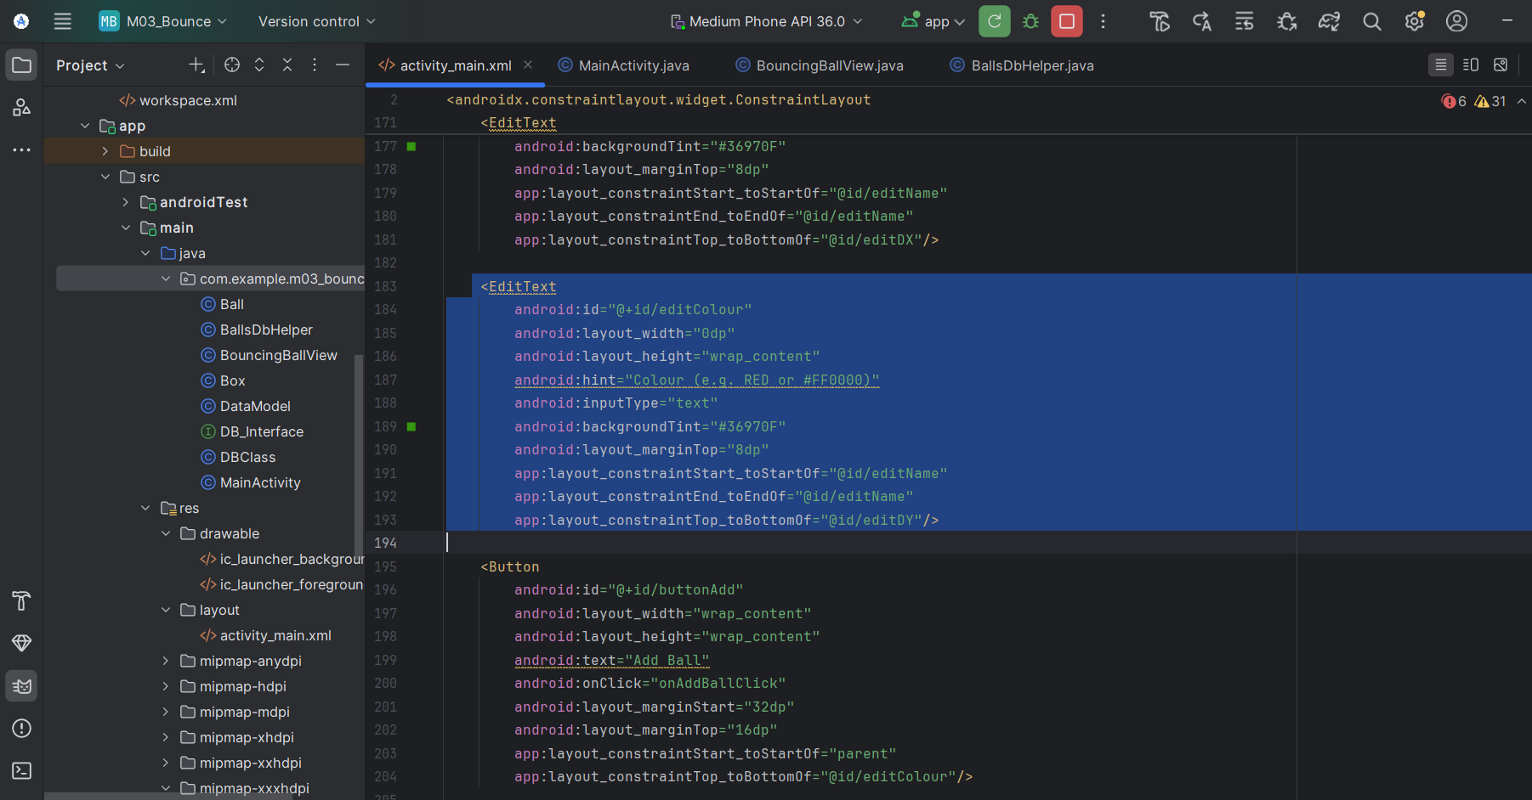

**X coordinate:**

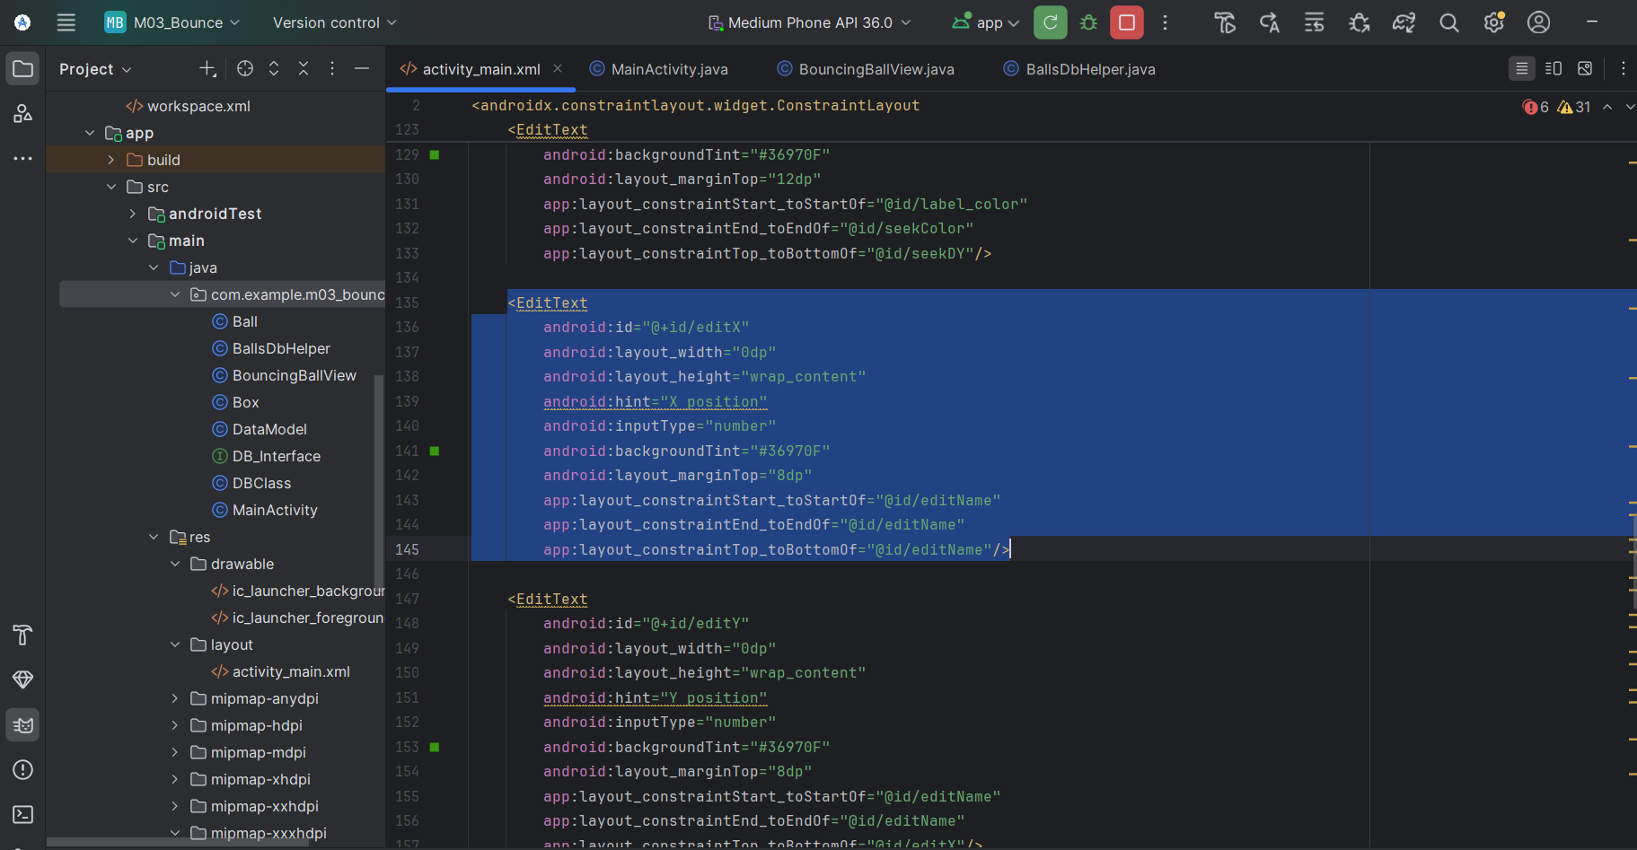

**Y coordinate:**

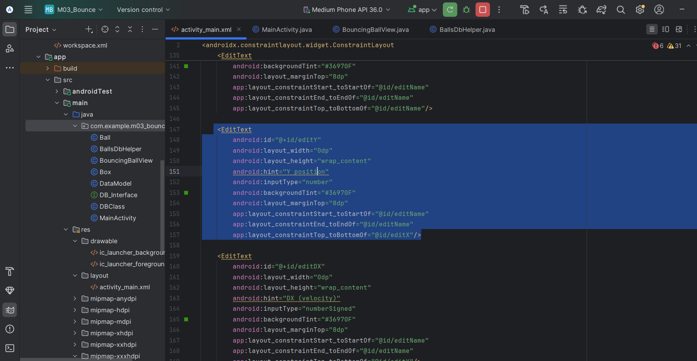

**DX (velocity in X direction):**

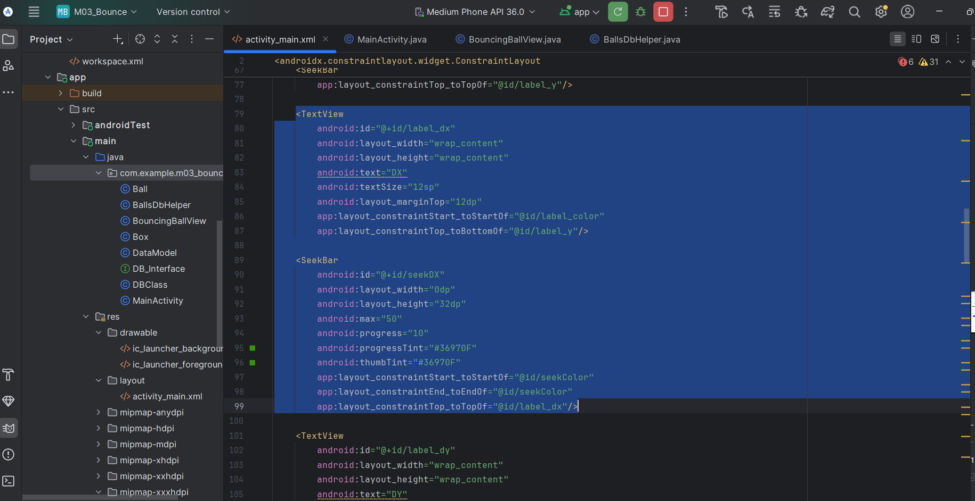

**DY (velocity in Y direction):**

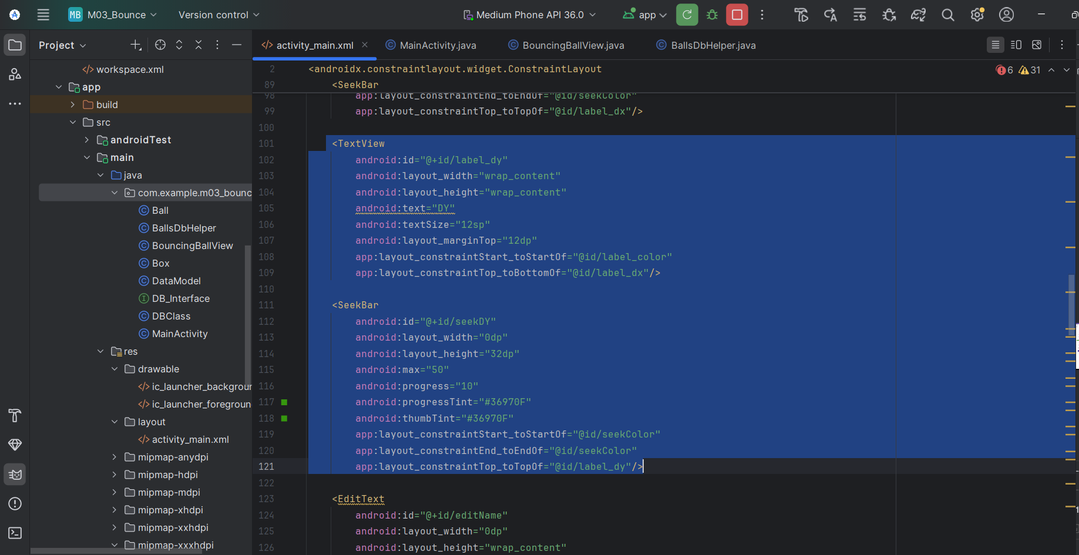

**Buttons:**

**Add – Insert the ball into the DB and launch it on screen:**

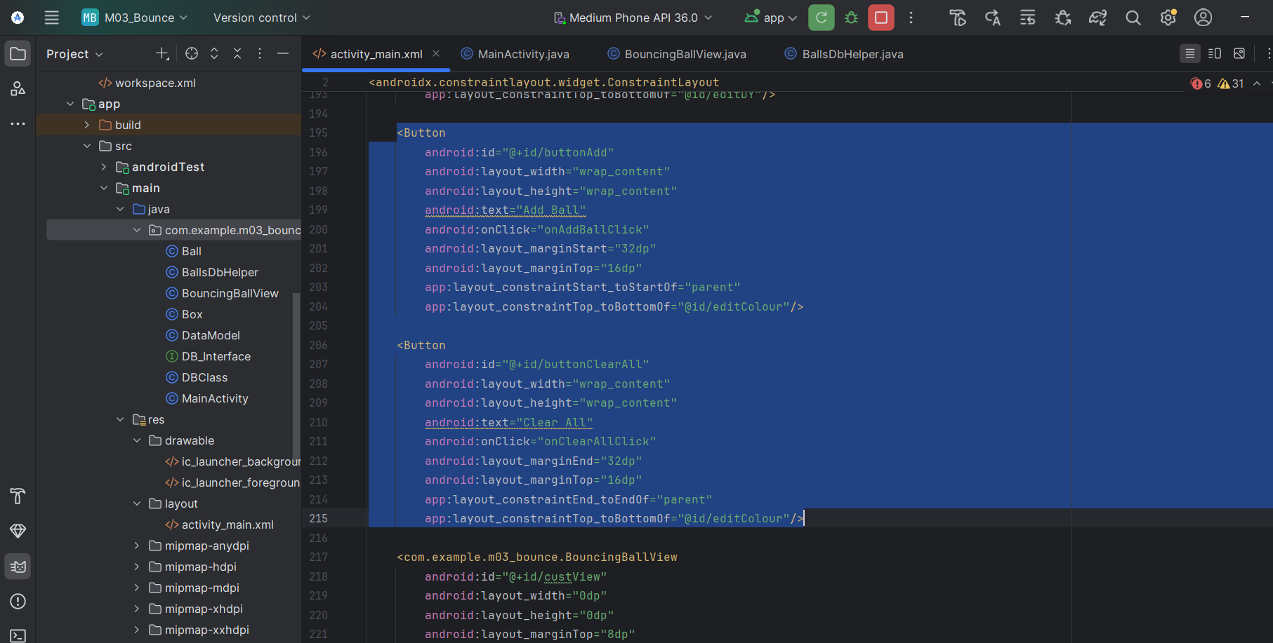

**Clear – Delete all balls from the DB and remove them from display:**

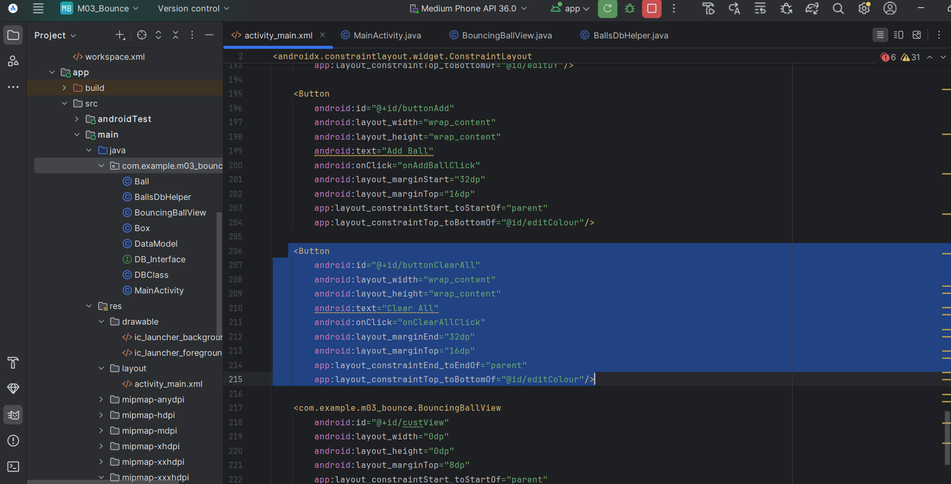

**After running:**

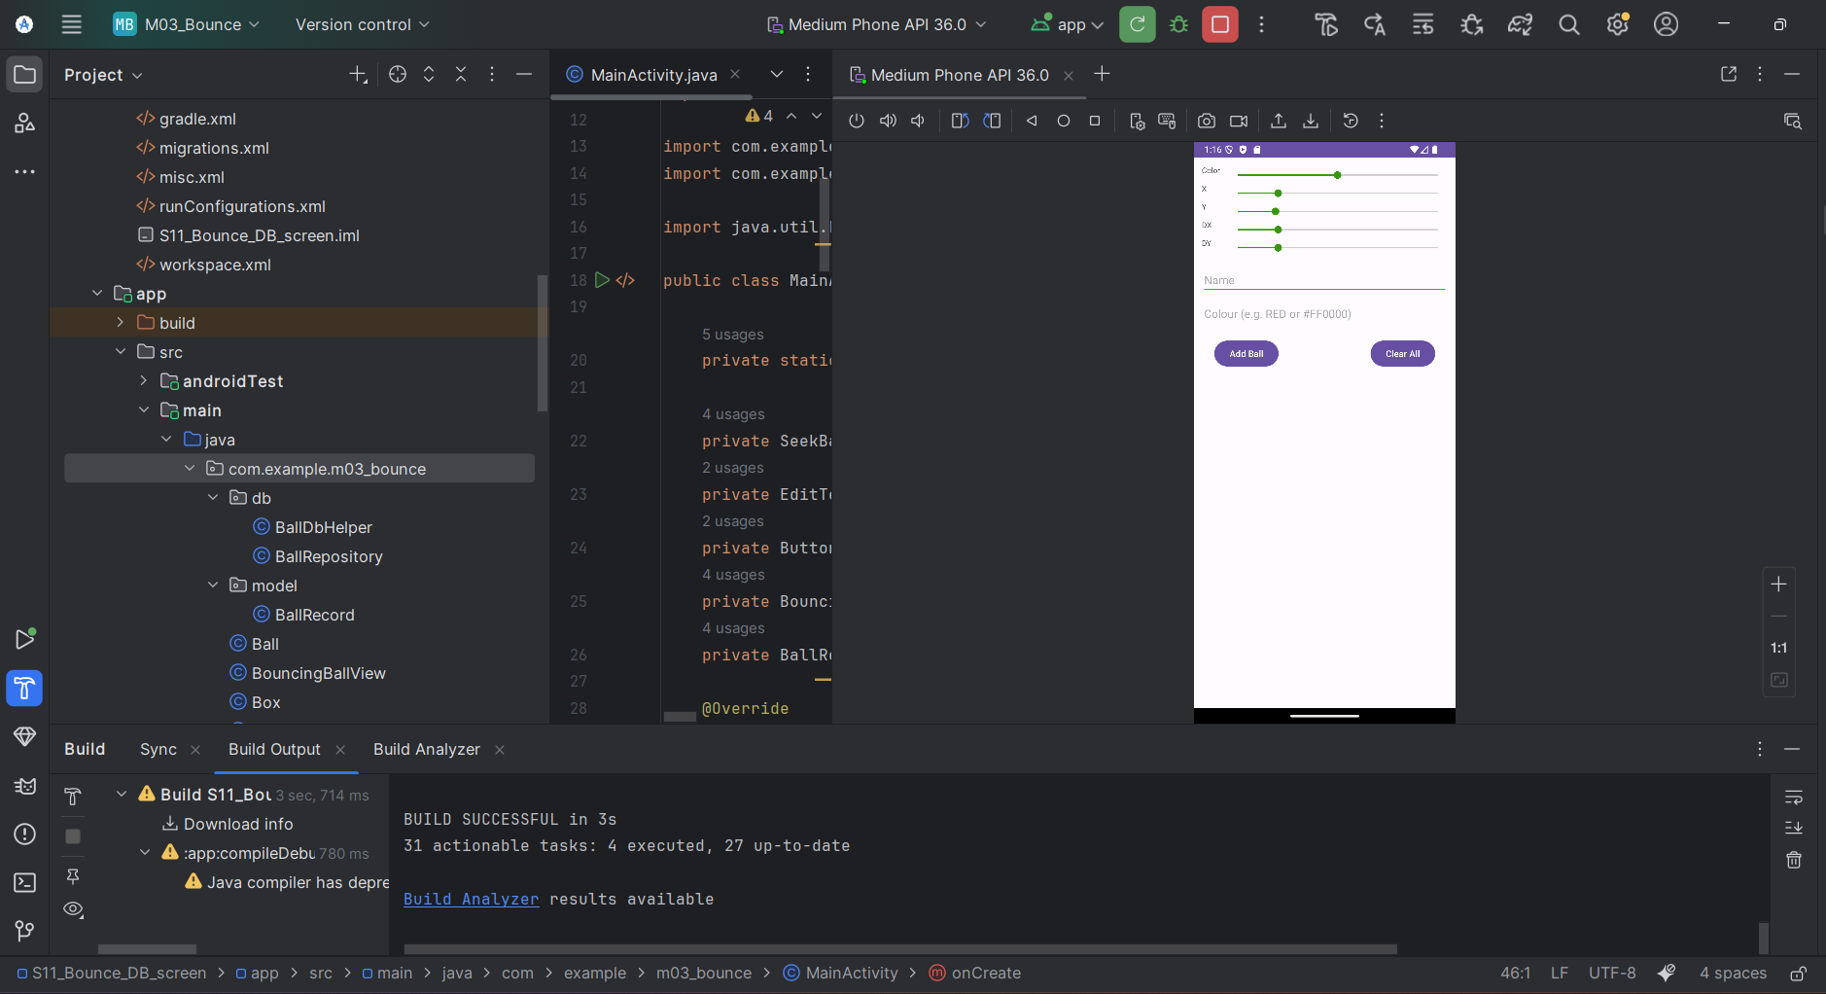

## Add Ball Data to Database and Launch Ball

Add Ball:

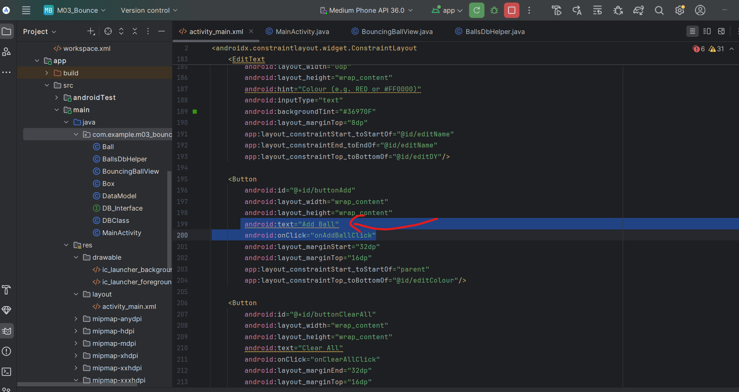

**After hitting Add ball button:**

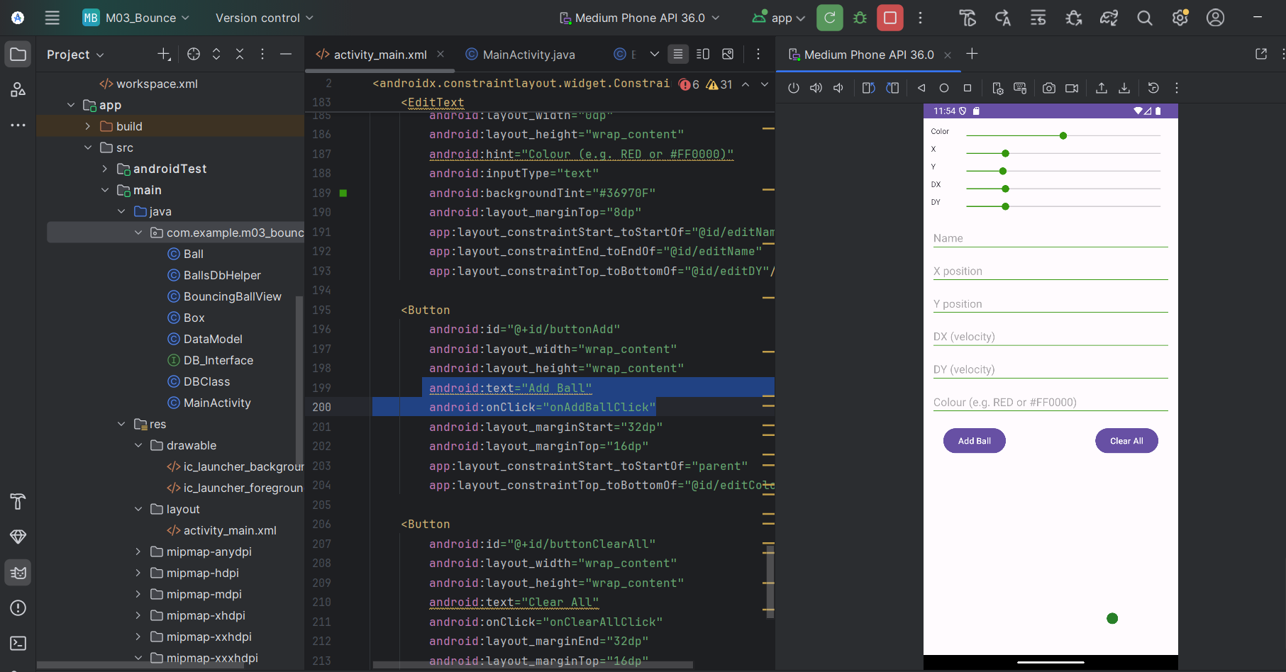

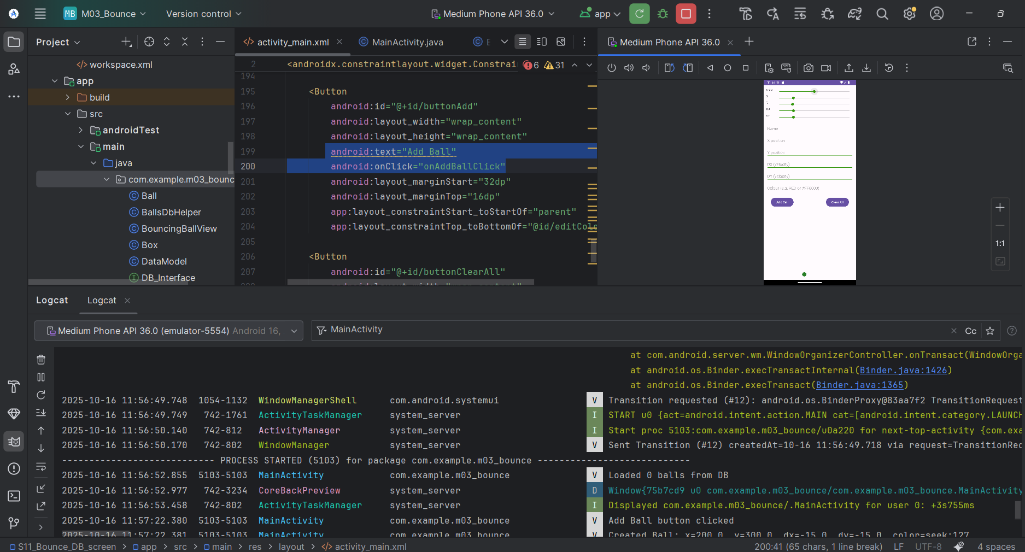

**Trying to change the colors:**

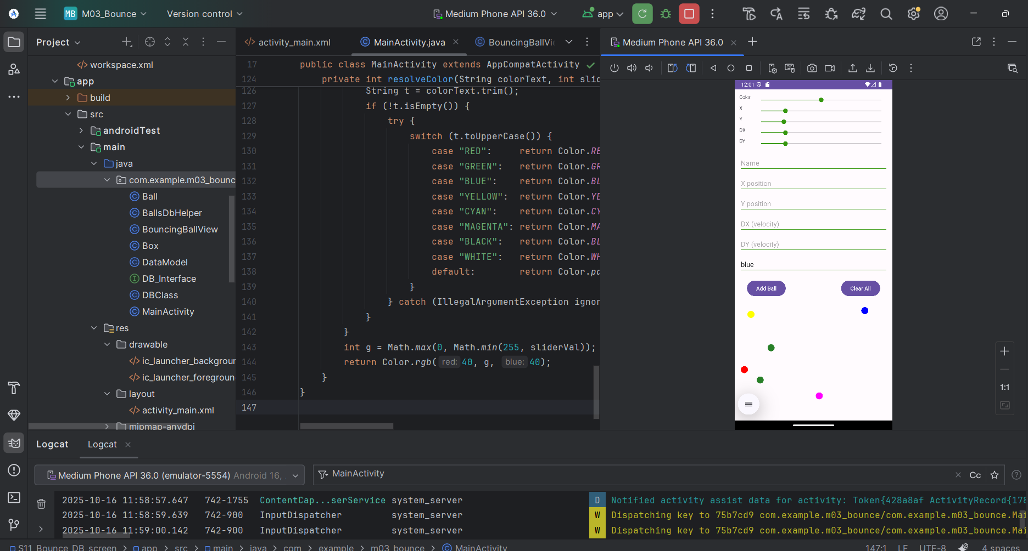

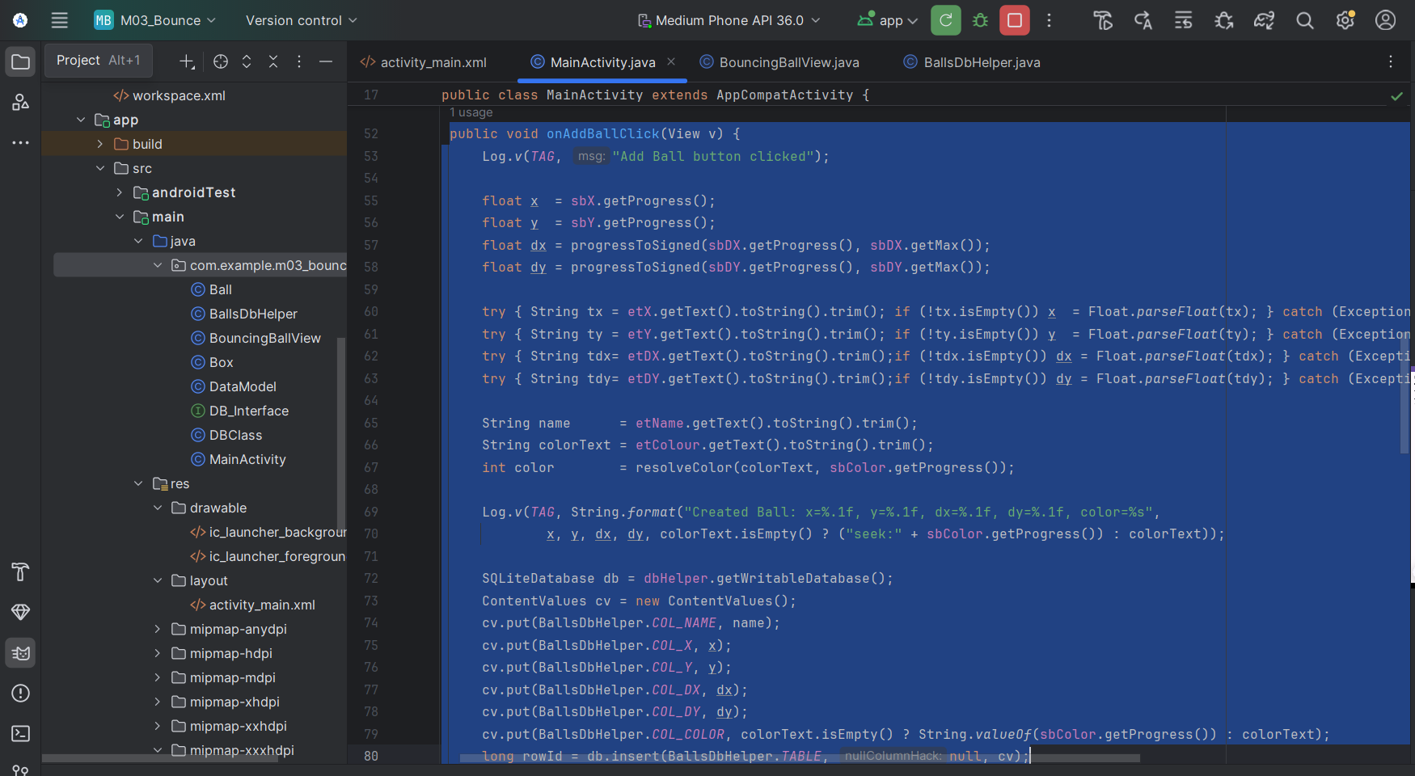

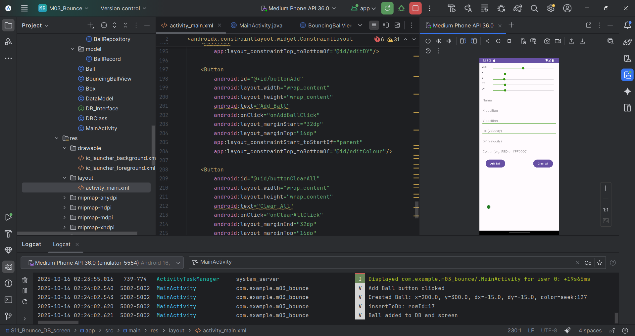

**The user may then enter more balls by updating ball data (name, x, y, dx, dy, colour) and selecting "Add" again.**

**I changed to :**

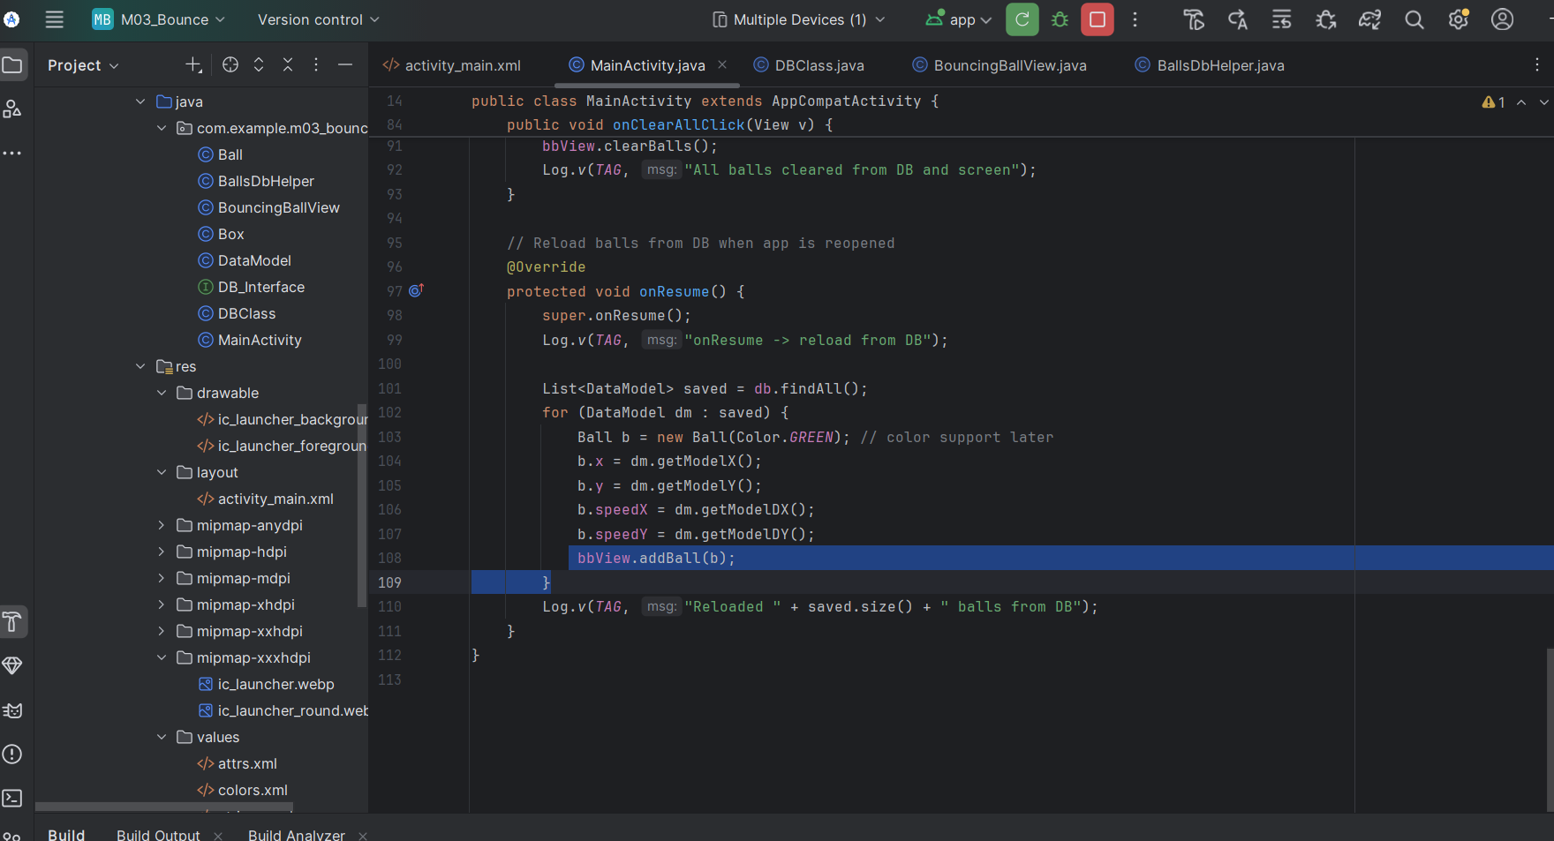

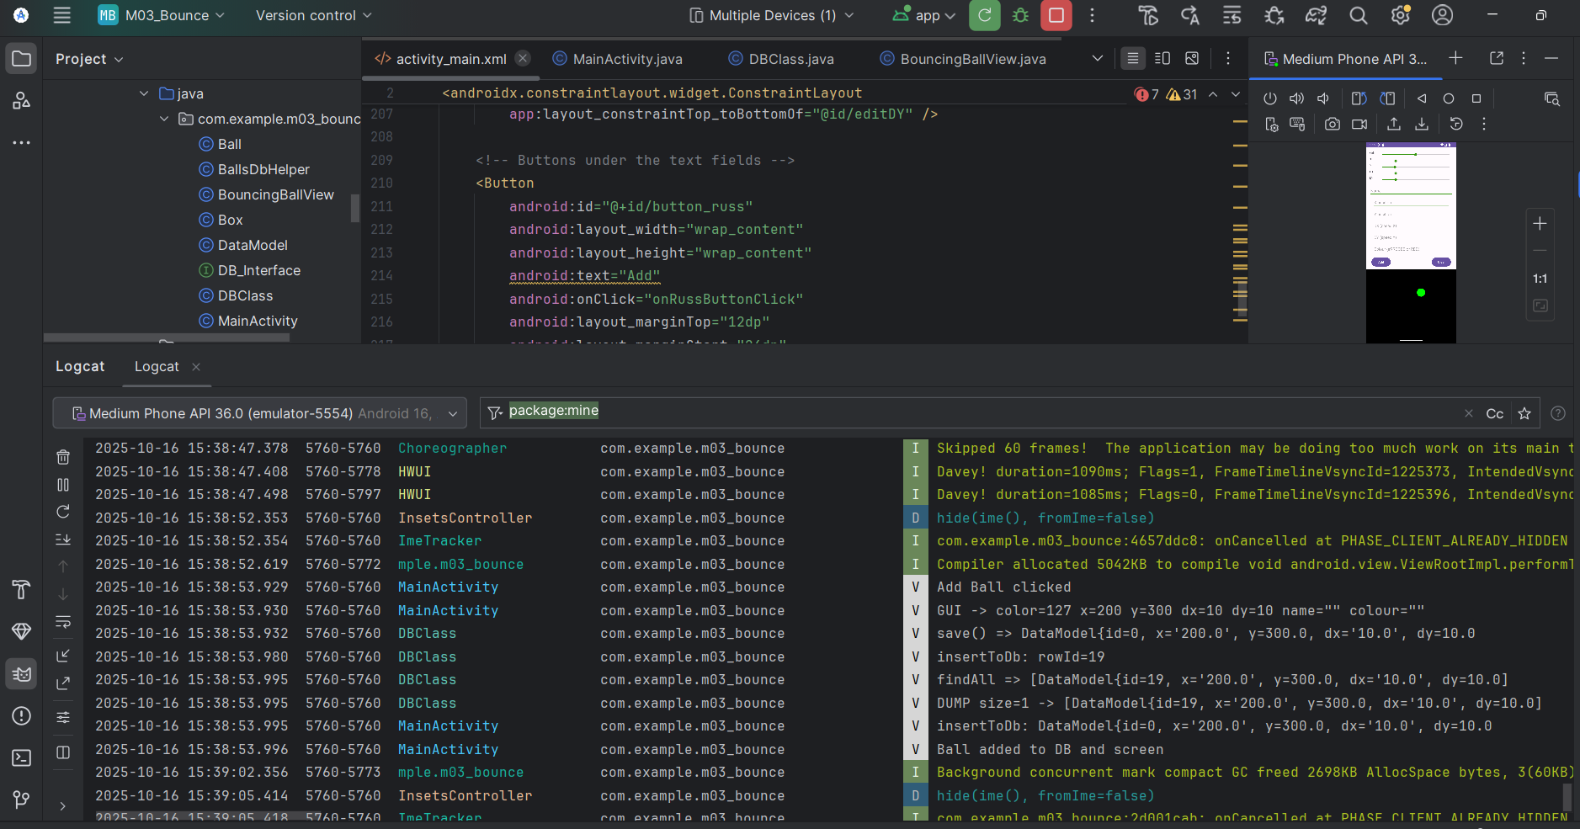

## The user may select "Clear" to delete all balls from the DB and the screen.

## Persistence Test:

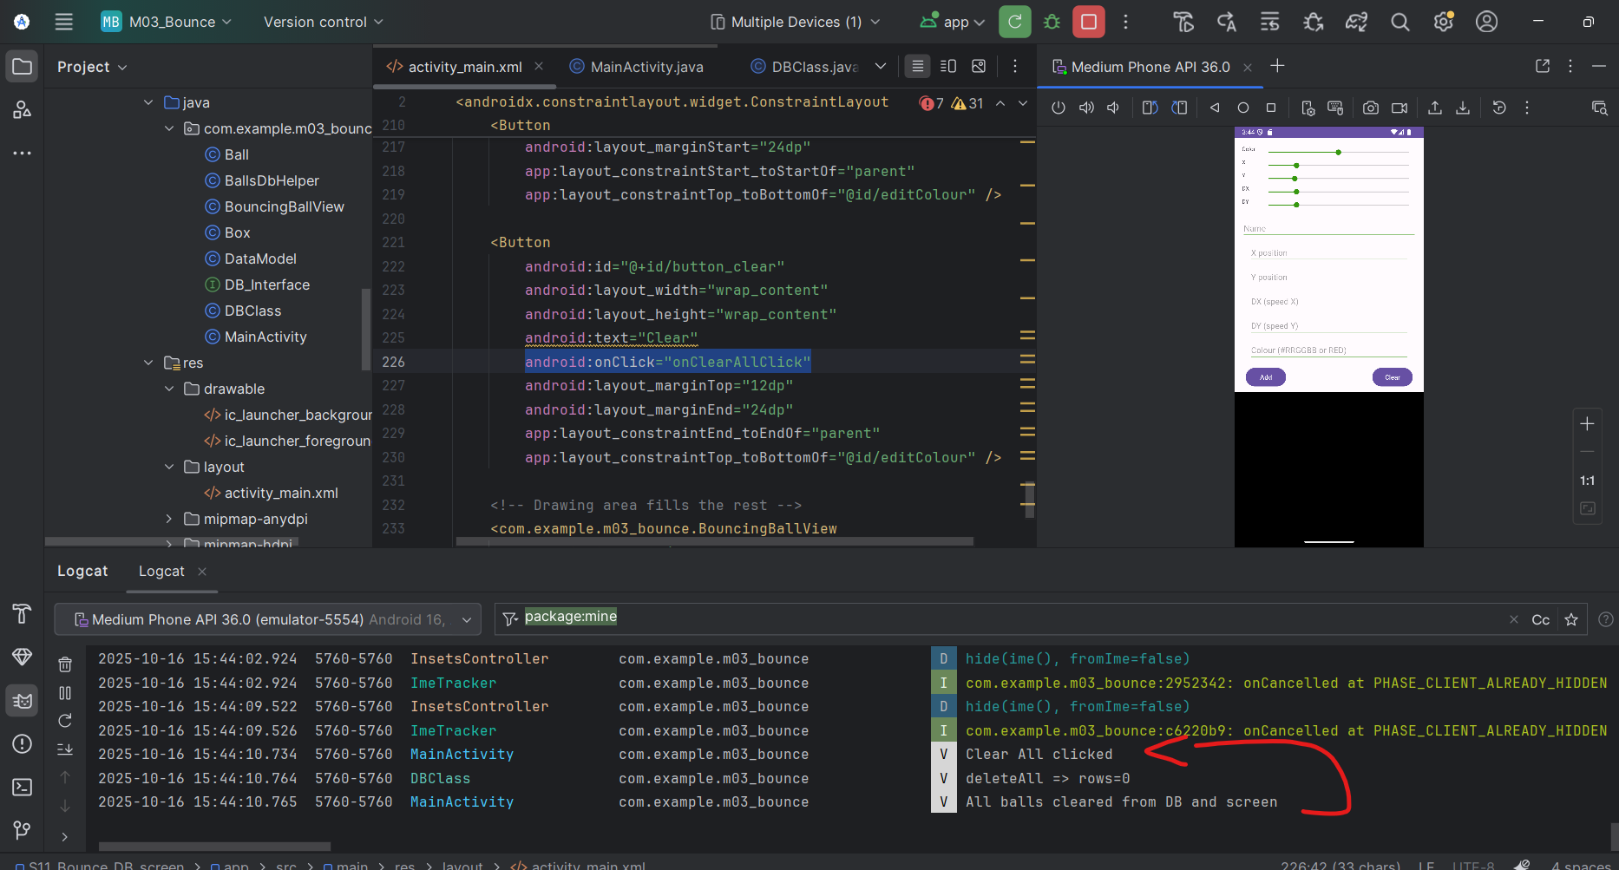

## The user may close the App (which saves ball data to the DB), then re-open it to get all DB balls re-started again (with ball data pulled from the DB). Use logs to show the data is pushed and pulled to/from the DB.

Saving (Push)

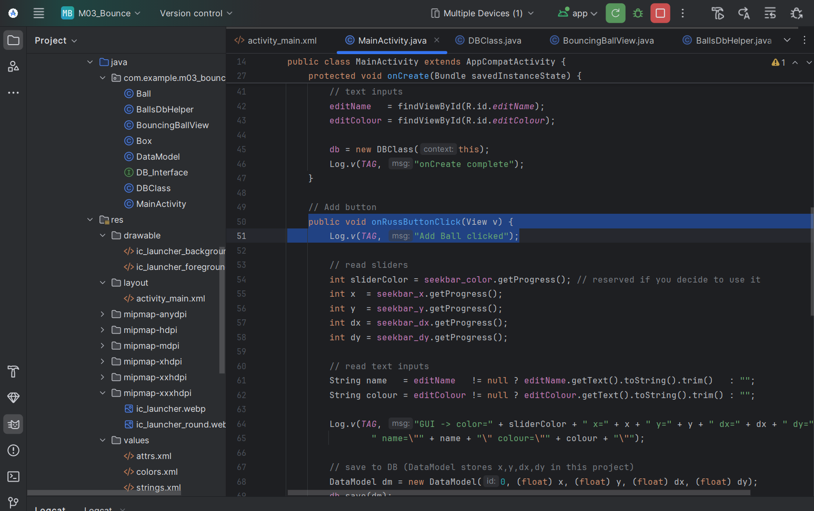

Reloading (Pull)

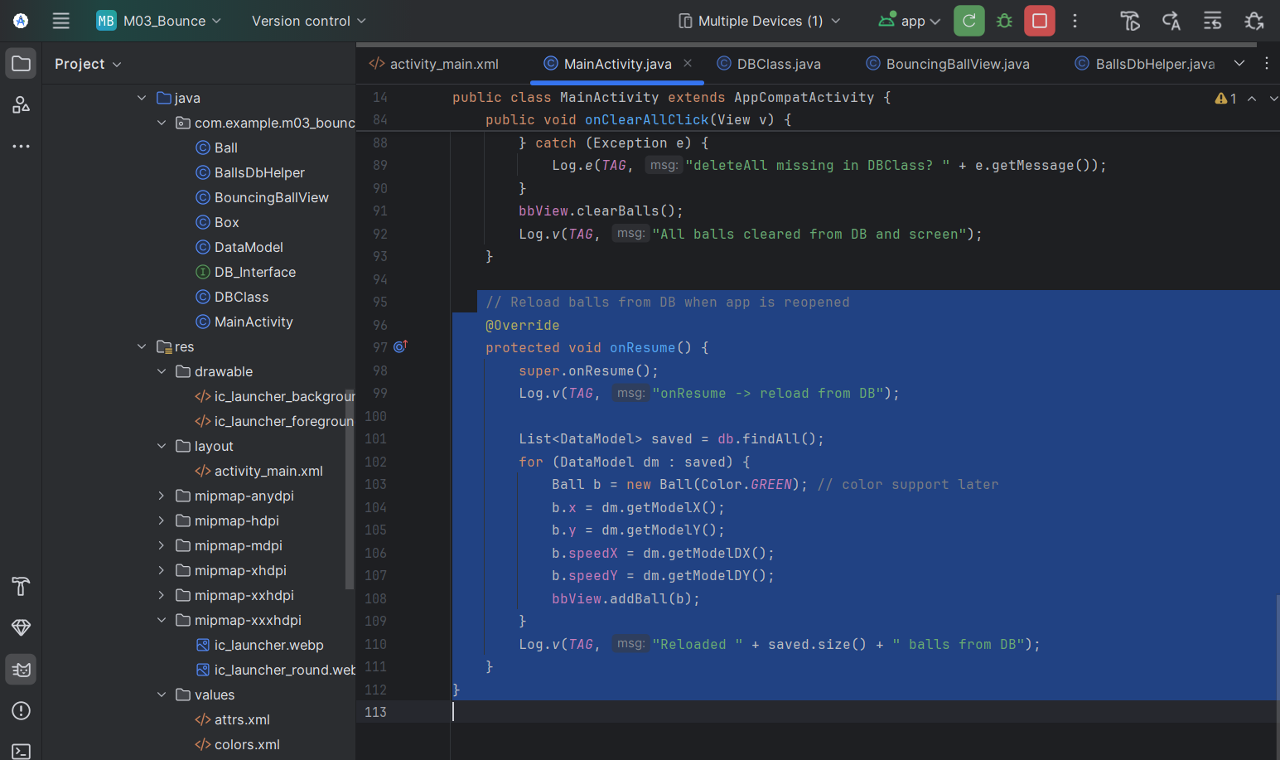

**Add ONE deliberate ball position and velocity AT A TIME:**

Previous Code:

// let the view do something

bbView.RussButtonPressed();

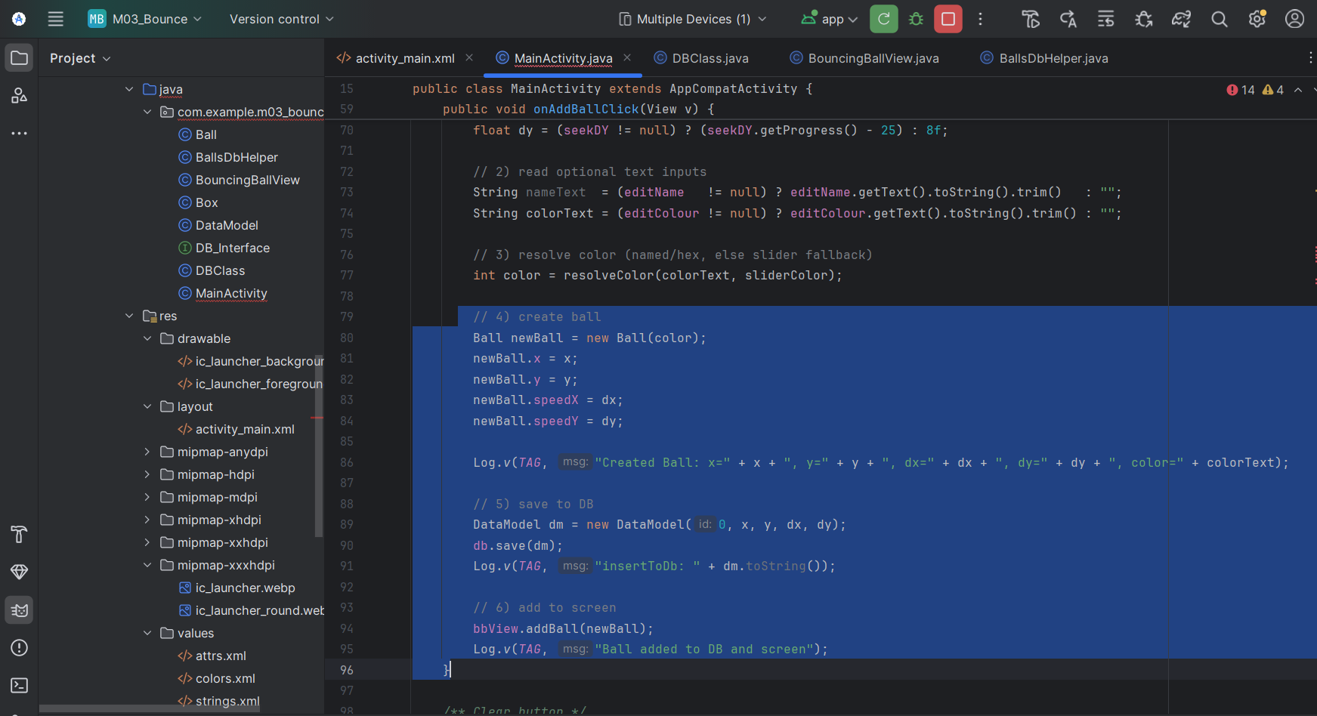

**Show Testing. Show the running app... that the ball is launched and the data is saved persistently in the DB.  Again, use logs and DB dumps to verify and prove the balls are persistently saved in the DB between runs.**

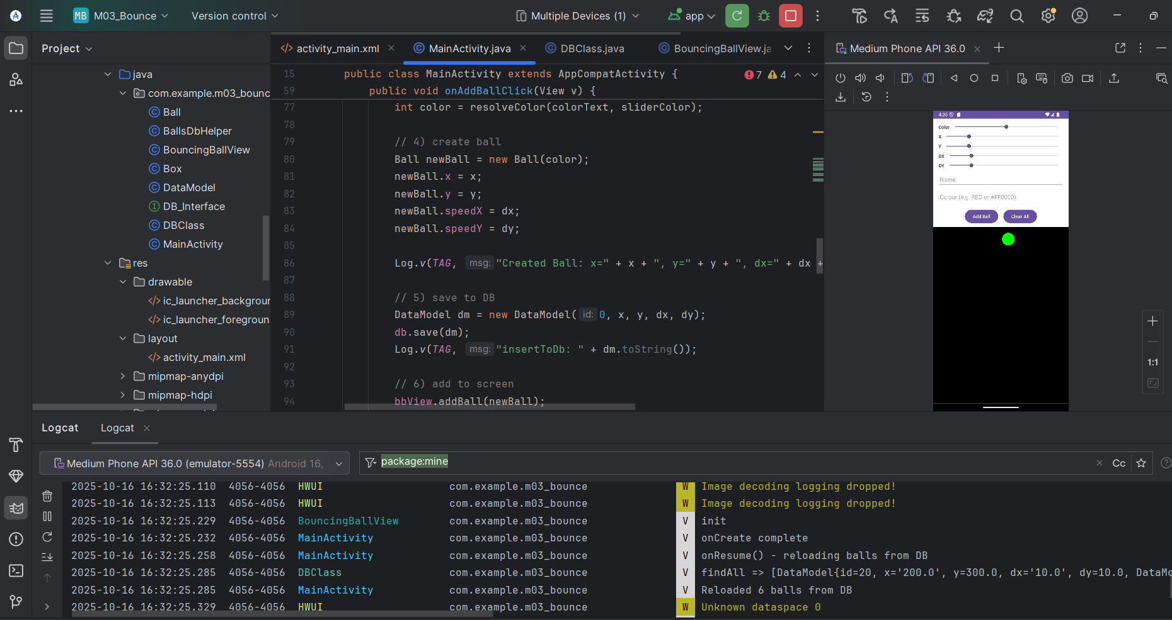

Testing:  
The app successfully launches a ball on-screen using the entered values. Logs confirm the ball was created and saved in the database.

insertBall:

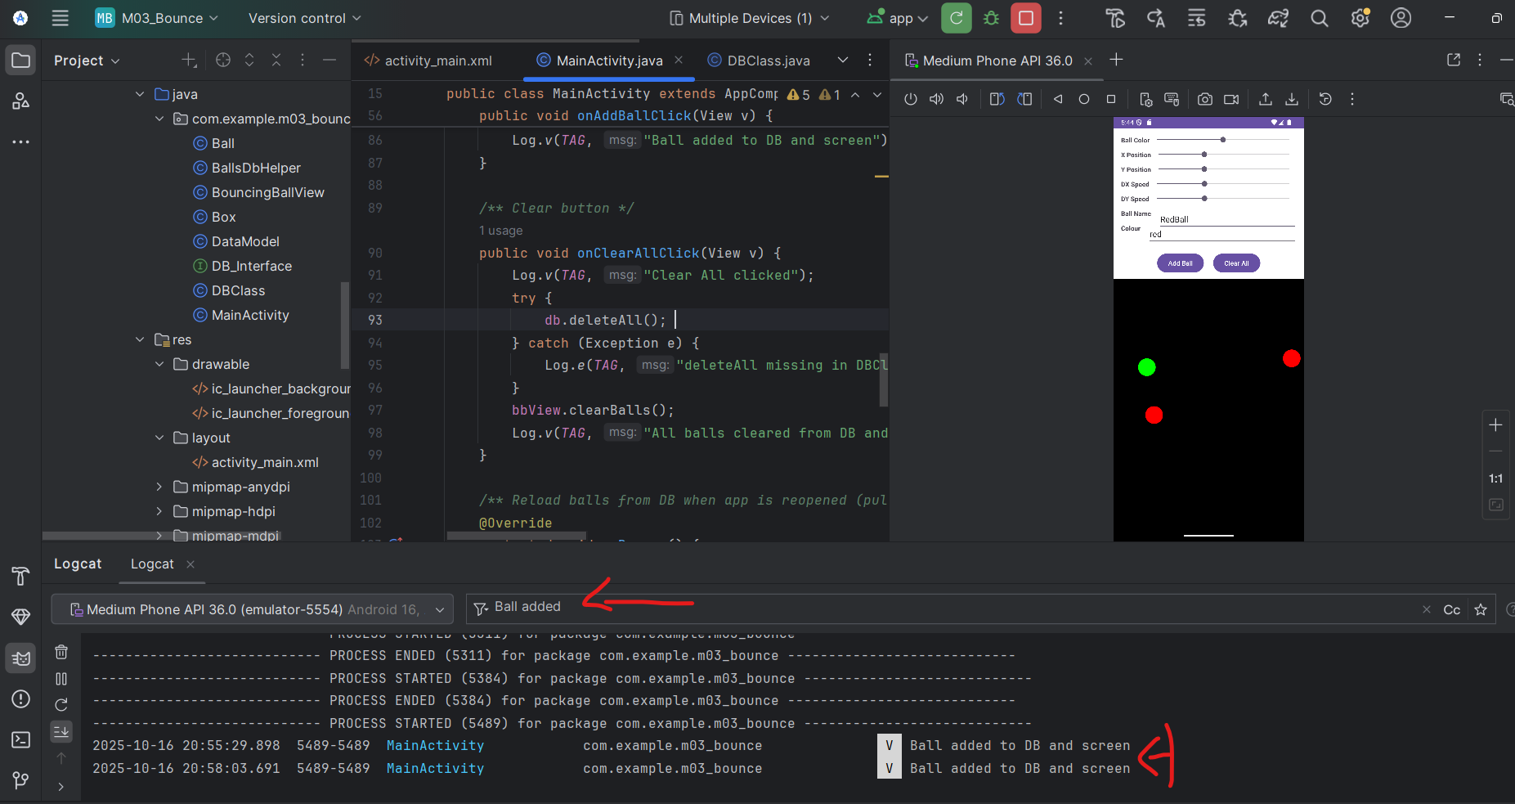

Reload logs:

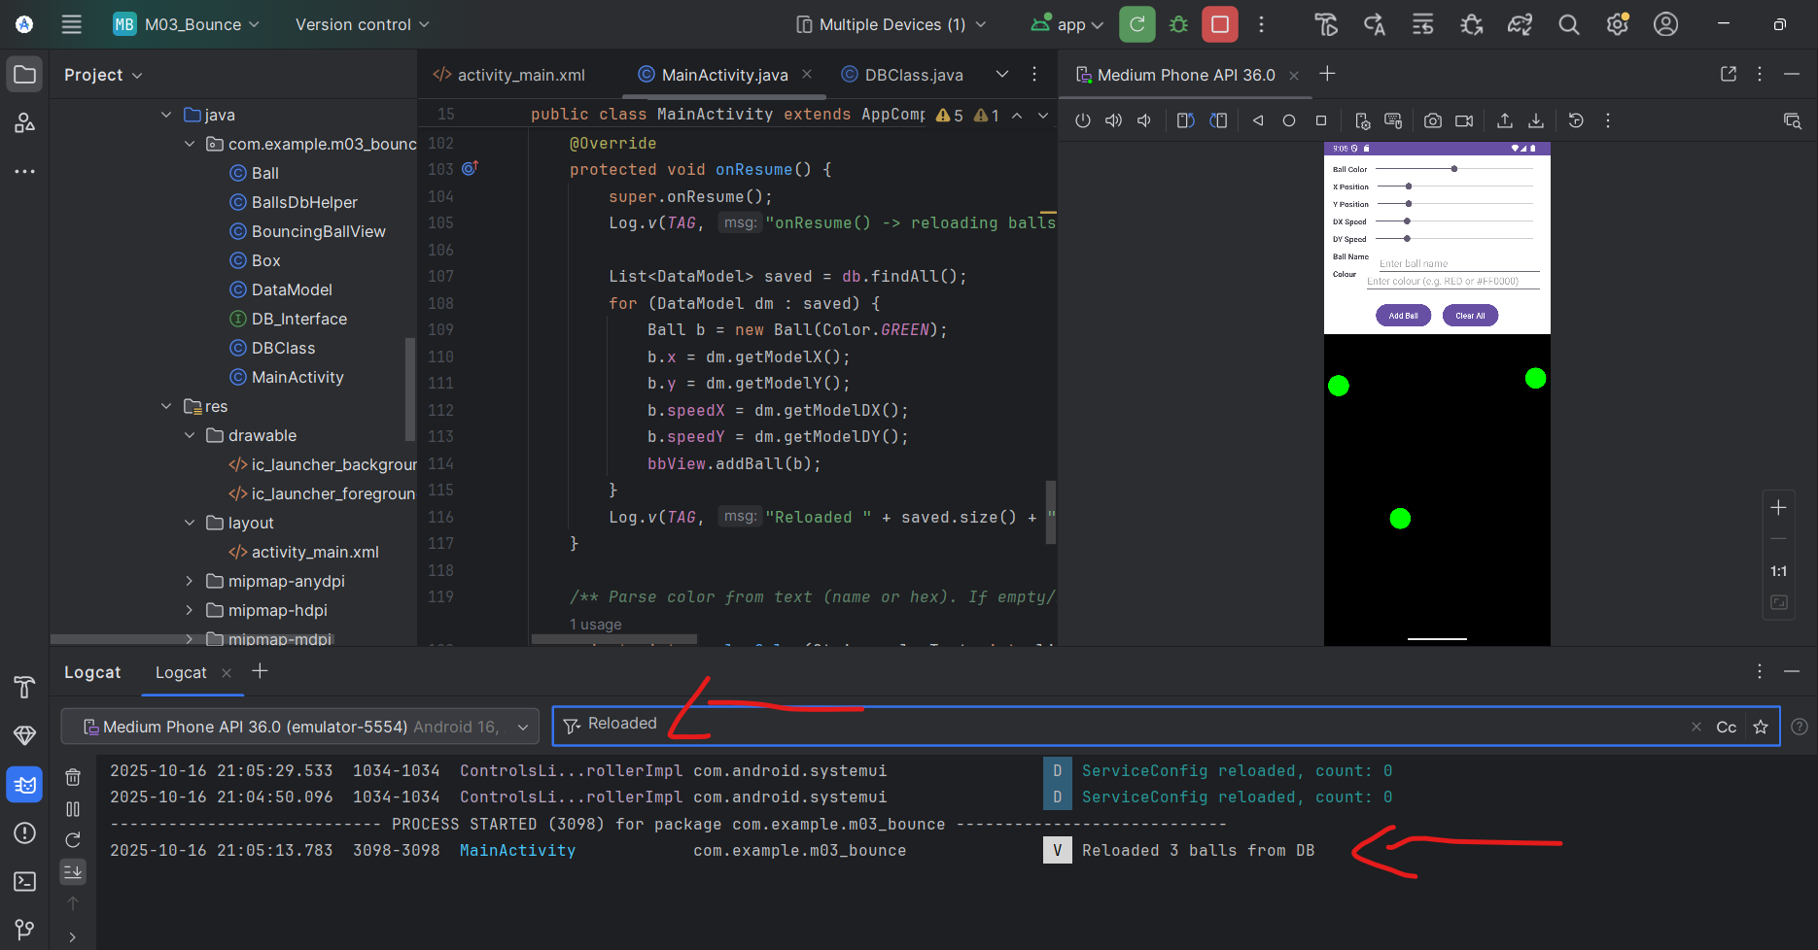

So These screenshots show that the ball’s data is saved to the database (insertBall) and reloaded from (onResume) after reopening the app, confirming full data persistence

**Saved in the SQLite database:**

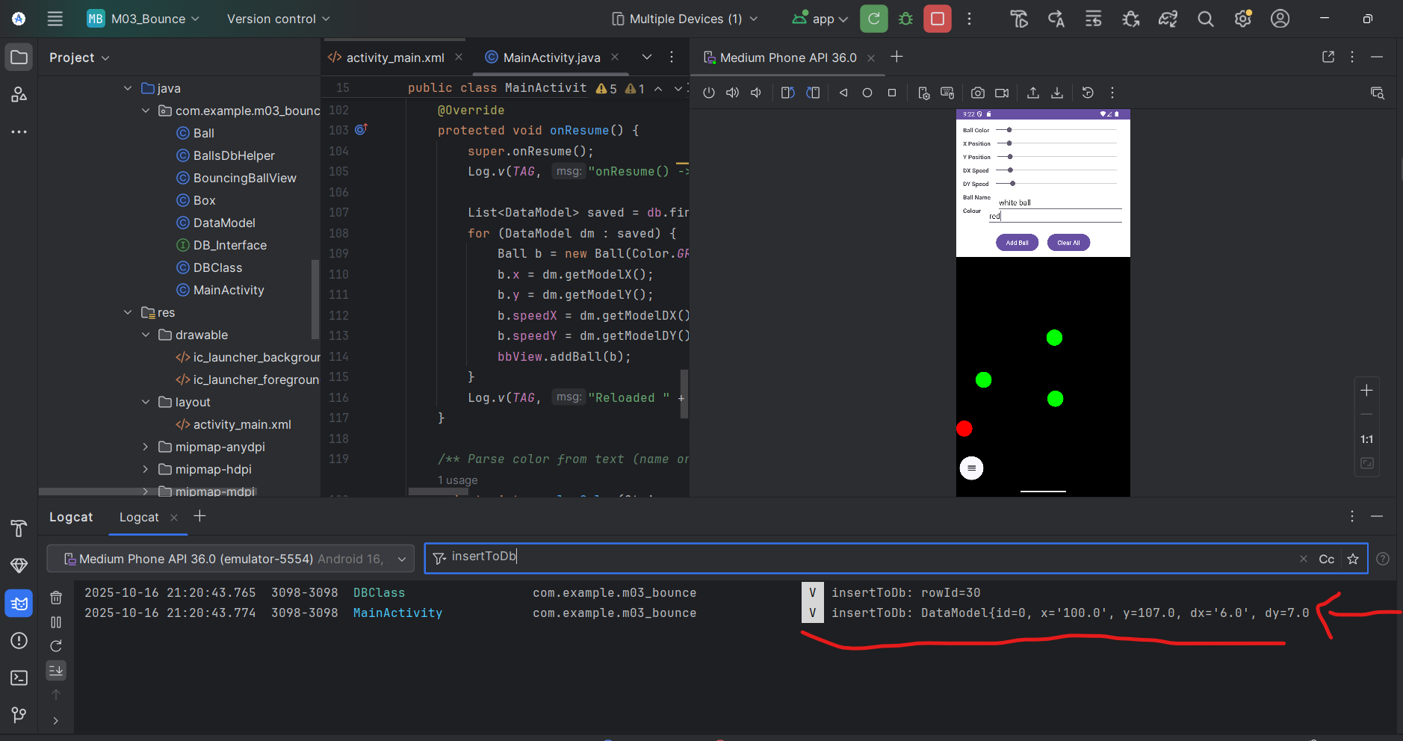

That screenshot shows that the ball data is being stored in the SQLite database

**Upload the DB from your platform, and onto your desktop.  Show the DB files, and data using a SQLite utility.**

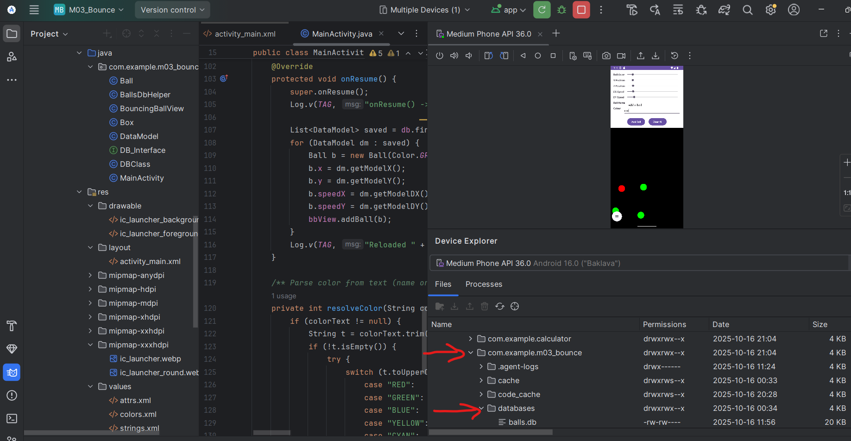

That screenshot shows the database file was successfully pulled from the emulator (shown in Device Explorer) and saved locally

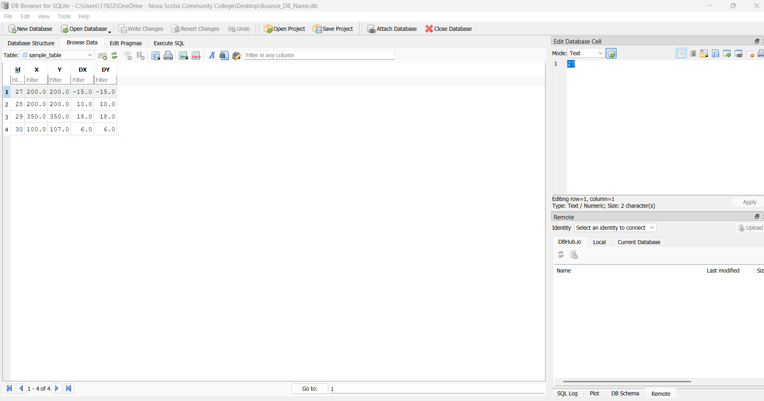

This screenshot demonstrates that the database file was successfully extracted from the emulator and opened in DB Browser for SQLite. The displayed table with X, Y, DX, and DY values confirms that the data has been stored correctly and can be accessed outside of Android Studio

**runtime verification:**

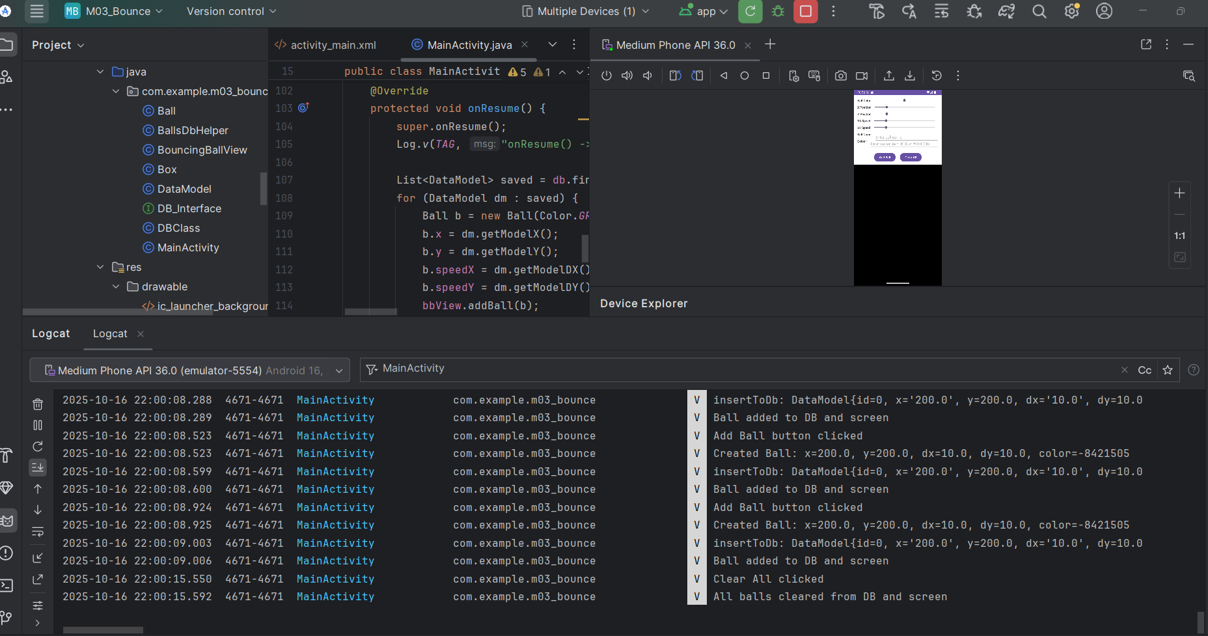

**This screenshot demonstrates the runtime process captured in Android Studio. The Logcat output confirms that multiple balls were successfully created, added to the SQLite database, and later removed using the ‘Clear All’ function, verifying that both insertion and deletion operations worked correctly**

**Logcat:**

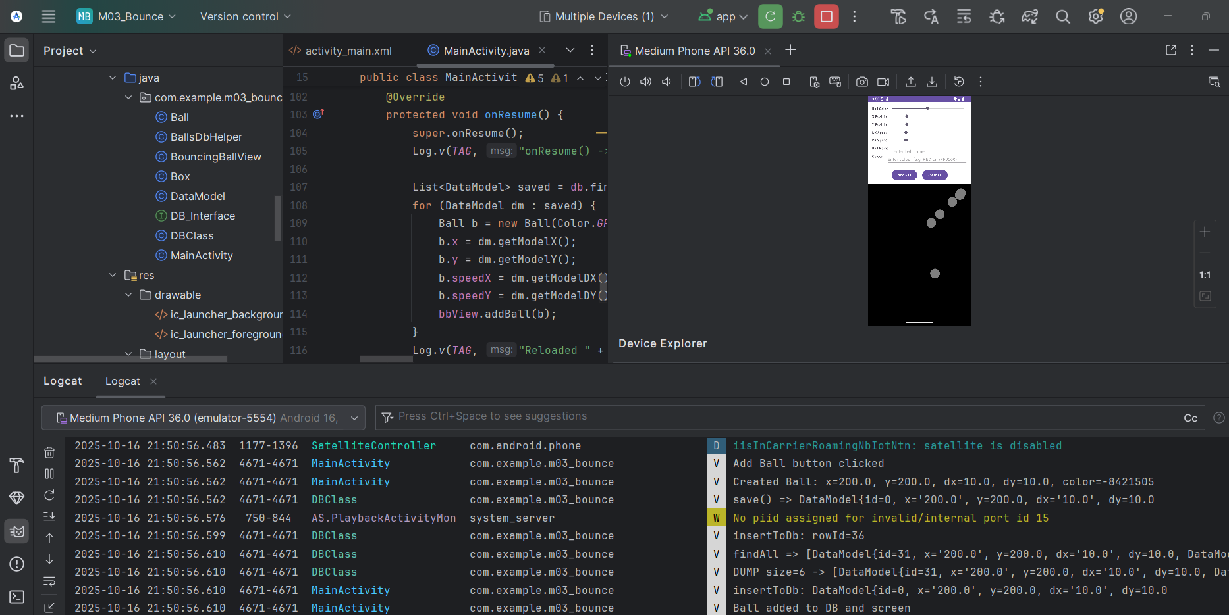

This screenshot shows the Logcat output confirming that the ‘Add Ball’ button was clicked and the InsertBall() method executed successfully. The messages indicate that each ball was created, added to the screen, and stored in the SQLite database